**MCS 2514 Computer Science 2**

Homework Four – Summer 2022

Prof. Khalil Khalaf

Write a program that has the implementation of two classes named as such:

* *Student*
* *StudentsContainer*

I provided you the class interfaces for both classes, and a simple test code inside main() that will help you validate your code. Also, I have done one implementation as an example, and the assignment is to provide the implementation of the rest of the class functions.

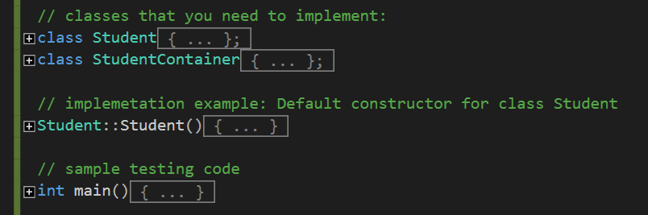

Keep in mind that you are responsible to submit error free code, in other words, if I test your code using a different main(), your program should 1) compile and 2) never crash on run time.

Validation:

* AddStudent() should return false if student is already in the container
* AddGrade() should return false if the grade is already in the container

Your functions should return true value once it completes successfully what it is supposed to do, otherwise false value.

Your implementation of functions should go in that same file as well just like I did with Student default constructor. You are NOT allowed to change any code that is inside the classed. Submit the file as is once done.

Output of the sample code that is provided inside main():

